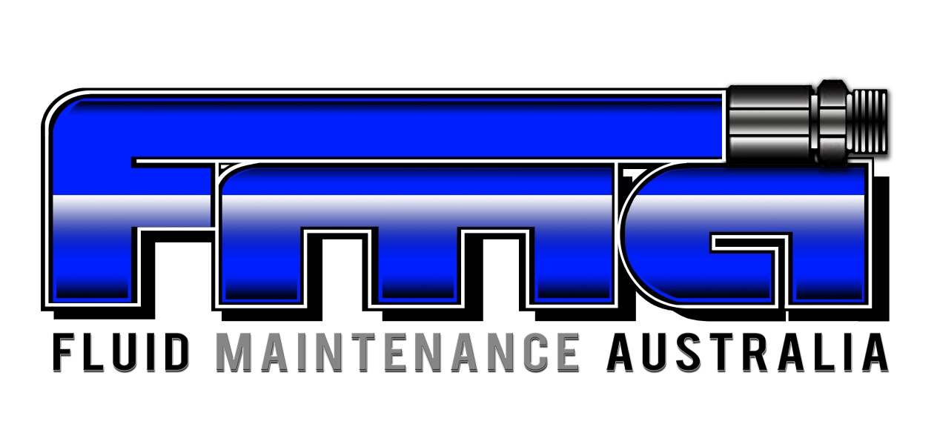

Title: Student Code of Conduct

Procedure Number: RTO-SM-PO001

Approvals
This procedure has been approved for use by the signatures below as the current edition, together with all amendments as listed below:
All other amendments are unapproved
Job Title | Name | Approval Signature
Managing Director | Andrew Freeman | 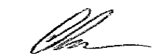
Quality/HR Manager | Emily Trevaskis

Table of Contents
1.0 SCOPE & PURPOSE 2
2.0 RESPONSIBILITIES 3
3.0 POLICY 3
4.0 REFERENCES 4
5.0 AMENDMENT RECORD 4

- SCOPE & PURPOSE

Fluid Maintenance Australia (FMA) is committed to creating a safe and supportive environment of which encourages and promotes the personal and professional development of its students.

This policy establishes the standard of conduct expected by all students enrolled at FMA.

All students are expected to conduct themselves in a manner consistent with this policy.

- RESPONSIBILITIES

All students are responsible for maintaining a safe, harmonious and tolerant environment.

Expectations include:
- must act in accordance with this policy;
- must read and familiarise themselves with FMA policies and procedures available on the FMA website and in the Student Handbook;
- ensure all personal details supplier are correct;
- read all relevant correspondence and information supplied by FMA.

Students are expected to:
- treat all other students and staff of FMA with respect, dignity, courtesy and sensitivity;
- act with impartiality, integrity and honesty in all their dealings with other students and staff;
- respect the privacy of other students and staff;
- comply with directions by FMA trainers;
- comply with all health and safety requirements and instructions given by FMA trainers and staff;

In relation to meeting the academic expectation, all students are required to abide by these principles:
- meet unit and course requirements to the best of their abilities;
- make genuine attempts to complete their course successfully by the required deadline;
- conduct themselves in a professional manner whilst undertaking industrial activities;
- provide constructive feedback to trainers.

- POLICY

A learner commits misconduct if they engage in actions which may adversely affect FMA or any member of staff or which may be prejudicial to the good order and conduct of FMA.

FMA will regulate learner behaviour wherever possible in an informal manner at the local level in recognition of an adult learning environment. However, where the matter is considered to be of a serious nature or where an informal process has not achieved the desired outcome a formal process involving management staff may be instituted. Learners may be required to enter into a written commitment of expectations regarding their conduct and behaviour.

Where inappropriate behaviour of a learner results in damage or loss of FMA property, the learner may be required to make restitution for any loss incurred. Illegal activities will be referred to the West Australian Police.

- REFERENCES

Australian Skills Quality Authority’s (ASQA) Standards for Registered Training Organisations 2015 (“the
Standards”)
Privacy Act 1988
Student Identifiers Act 2014
Code of Conduct for Training and Assessing
RTO-TA-PO001 Training and Assessment Policy
RTO-CG-PO003 Complaints & Appeals Policy

- AMENDMENT RECORD

Version | Amendment | Page | Description | Date
1 | 0 | All | First Issue. This procedure was formerly FMA-RTO-PO0011. Full review of procedure to be inline with requirements of ISO9001:2015 | 06/10/2016
THIS DOCUMENT IS NON-CONTROLLED WHEN PRINTED
To be used for reference purposes only
Refer to the electronic copy for latest revision

