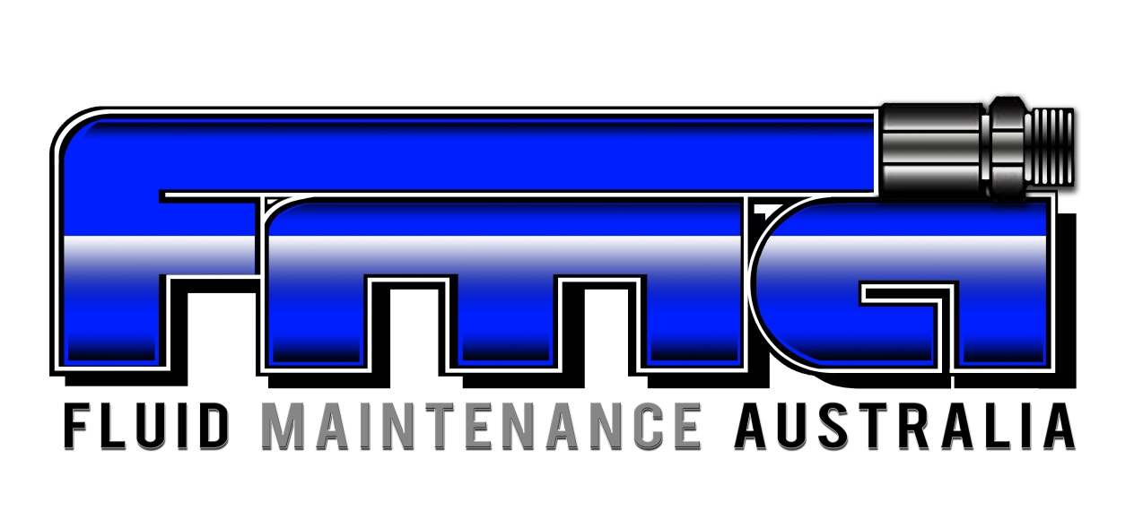

Title: Industry Consultation

Procedure Number: RTO-CG-PO002

Approvals
This procedure has been approved for use by the signatures below as the current edition, together with all amendments as listed below:
All other amendments are unapproved
Job Title | Name | Approval Signature
Managing Director | Andrew Freeman | 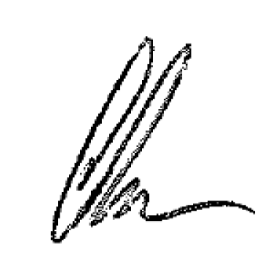
Quality/HR Manager | Emily Trevaskis | 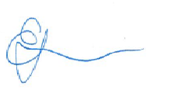

Table of Contents
1.0 SCOPE & PURPOSE 3
2.0 RESPONSIBILITIES 3
3.0 POLICY 3
4.0 PROCEDURE 3
5.0 DOCUMENTATION & RECORDS 4
6.0 REFERENCES 4
7.0 AMENDMENT RECORD 5

- SCOPE & PURPOSE

Fluid Maintenance Australia (FMA) will ensure engagement with industry representatives as a key element in developing training and assessment strategies to ensure its resources accurately reflect the needs of industry and the expectations of its employers.

This Policy applies to FMA, employees and any third party acting on FMA’s behalf.

- RESPONSIBILITIES

Training Management Group: responsible for ensuring the overall compliance to this procedure and ensuring effective management of liaising with the relevant industry experts.

Industry Partner Responsibility;
- To provide ethical and accurate information
- To provide FMA permission to use information provided in industry for advertising and marketing purposes
- To provide feedback in relation to information requested by FMA in a timely manner
- To seek permission from FMA to use information received through industry liaison in advertising and marketing

- POLICY

FMA will ensure:
- to ethically and accurately portray information acquired through industry consultation;
- to use information and photos/examples of information gathered through industry consultation in marketing and advertising material with prior approval as per Copyright Legislation;
- to review and discard information not relevant to the courses delivered by FMA appropriately;
- to use all information provided by industry to audit and improve training methods, delivery and assessments to ensure continual improvement whilst remaining on top of any changes within the industry.

As an FMA Industry Partner, they have the right for:
- information provided to be used ethically and accurately;
- to receive fair and valid feedback;
- to have adequate time to reply to information requests;
- acknowledgement in all references to the collaboration with FMA.

- PROCEDURE

FMA will apply various ways to seek industry feedback on the appropriateness of its training and assessment strategies and resources. This will include: surveys, direct engagement, general communications and engaging with industry members to contribute to assessment evidence as appropriate.

  - Employer Surveys

Employer Feedback surveys are sent to learner’s employer (when appropriate) after the unit completion.

  - Direct industry engagement

FMA will undertake direct industry engagement through its position as a supplier undertaking the units of competency within its training scope. The information gathered as a result of direct engagement acts as a point of reference for future activities and quality compliance.

Identified opportunities for improvement are to be recorded on the Issues & Risks Register and relevant actions raised subsequently.

FMA is committed to delivering training programs that build industry capacity. Training and assessment strategies applied by FMA will be developed in direct consultation with employers and the wider industry and other stakeholders as appropriate.

  - Monitoring, Evaluation & Review

This policy shall be reviewed in line with FMA document requirements unless the following occurs:
- Changes to the business activities that relate to this policy;
- New business activities impacting this policy;
- Changes to internal controls relating to this policy;
- Changes to legislative and/or regulatory requirements.

- DOCUMENTATION & RECORDS

Number and Title | Document Storage Location | Record Location | Retention Period | Responsibility

- REFERENCES

Standards for Registered Training Organisations 2015 (“the Standards”)
National Vocational Education and Training Regulator Act 2011
Copyright Act 1968
Privacy Act 1988
QMS-QU-PR003 Management Review Procedure
QMS-QU-PR006 Continual Improvement Procedure
RTO-CG-PR001 Accuracy & Integrity Of Marketing Policy
RTO-TA-PO001 Training & Assessment Policy

- AMENDMENT RECORD

Version | Amendment | Page | Description | Date
1 | 0 | All | First Issue. This procedure was formerly FMA-RTO-PO0007. Full review of procedure to be inline with requirements of ISO9001:2015 | 04/10/2016
THIS DOCUMENT IS NON-CONTROLLED WHEN PRINTED
To be used for reference purposes only
Refer to the electronic copy for latest revision

